Dog Pulling on Leash

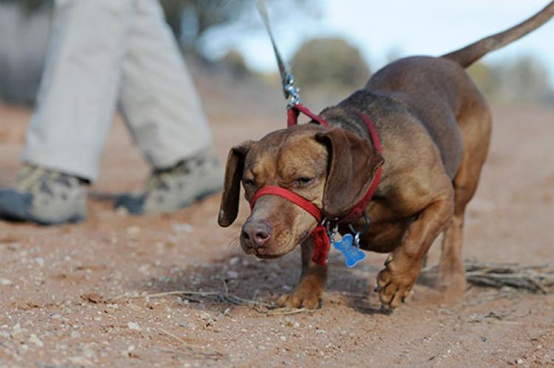
Most dogs want to go out for walks and get very excited when the leash is brought out. But do you have one of those dogs who is so enthusiastic that she literally pulls you out the door?
Walking should be fun for both you and your dog — and there are some things you can do to make it so. Start by checking your dog’s collar. It should be snug enough so she cannot pull out of it, but not so tight that you can’t put a finger or two between the collar and her neck.
If your dog is especially rambunctious, one strategy you can try is playing with her in your yard first to release some of her excess energy. You will find that a tired dog can focus and will learn more easily than a wired dog.

Strategies to try
There are several different ways to teach a dog how to walk nicely on leash. One way is the “red light, green light” game. Here’s how it works: Do the training initially in your home or yard, someplace without a lot of distractions. Put a four- to six-foot lead on your dog’s collar and start to walk with her. If she walks without pulling, praise her and continue walking. If she pulls on the lead, stop and wait until she stops pulling. As soon as the tension on the lead is released, praise her, offer a quick treat and then continue walking.
Consistency is important when teaching loose-leash walking. If you stop when your dog pulls four out of five times (rather than every time), she’ll learn that pulling can still result in the intended reward — moving forward. She’s thinking, “If it worked once, it will probably work again.” Be patient: If your dog has learned to pull on the leash, it might take her a while to stop pulling forward, even if you are stopped.
Here’s another strategy to try: If your dog continues to pull after you stop walking, turn and walk the other way. A change in direction will cause her to be behind you. Then, as she comes by, you can get her to focus on you with praise and a treat. Don’t yank the leash when you change directions. You can also try a lot of random changes of direction, so the dog gets used to focusing attention on you and moves with you. This technique is called “crazy walking” because instead of walking in a straight line to get from point A to point B, you are moving in crazy, unpredictable directions.
In addition, whenever your dog walks next to you, reward her for “being in position” or for simply walking with a loose leash near you. The more you reward her, the more she’ll want to hang out near you. The reward doesn’t have to be a treat; praise, petting and attention are also rewarding to your dog.

What not to do
If your dog is pulling or not listening to you while you’re walking together, please do not use leash corrections (e.g., jerk or popping the leash, forcefully pulling the dog in the other direction) and avoid using pinch or prong collars or chain collars (aka “choke chains”). These methods can physically harm your dog, can make pulling on the leash worse and can even exacerbate behavioral issues, such as lunging at another dog while on leash. Walking should be a fun experience for your dog. Leash corrections and punitive collars can make it scary and unpleasant instead.

Tools that can help
To teach our dogs how to walk nicely on leash, sometimes we need a bit more help. Perhaps your dog is strong or large and no matter how hard you try to successfully implement the strategies mentioned above, she continues to pull. What to do? Here are some training tools that can help:
- Head halter. A dog head halter is similar to a horse halter: There are straps around the nose and behind the ears. The dog’s lead is attached to a ring at the bottom of the nose strap. Head halters operate on the simple principle that a dog will follow where his head leads him. Dogs can eat, drink, pant and bark while wearing a halter, and these devices will not choke or pinch your dog. Popular brands of head halters are Halti and Gentle Leader.
- Training harness. A typical dog harness has a clip in the back to which the leash attaches. On a training harness, the leash attaches in the front, at the dog’s chest, which allows you to have more control when your dog pulls. When pressure is applied on the leash, the dog’s shoulders are turned and forward momentum stops. Brand names of training harnesses include PetSafe’s Easy Walk, Halti, SENSE-ation and Freedom.
There are many different versions and brands of head halters and training harnesses. The size of your dog, the strength with which your dog pulls and the fit of the device itself all need to be taken into account when choosing one of these tools. Generally speaking, head halters are nice for larger, stronger dogs because the lead attaches to the nose loop instead of the neck, allowing you to gently guide the dog’s direction and giving you more control. However, for smaller dogs, dogs who’ve had neck injuries or those with a short muzzle, a harness might be the better option.
No matter which device you buy, make sure you fit it properly to your dog. On head halters, the neck strap sits just behind the ears, high on the neck. The configuration of the nose strap may differ slightly, depending on the brand, but it should be adjusted so that it cannot slide off the end of the dog’s nose. Make sure the attachment ring (to which you attach the lead) is under the dog’s chin. The instructions that come with the halter will give you more tips on fitting it. The same is true for training harnesses: Each harness is constructed and fits a little differently, so make sure that you read the instructions.
How will your dog react when you put one of these devices on her? Most dogs are OK with wearing a harness. Wearing a head halter, however, can be a strange experience for dogs who have not worn one before. When you put the halter on her for the first time, your dog will probably try to get it off by pawing at it. To divert her attention from the foreign object on her head, get her moving. Start walking and keep her walking, praising her and offering small treats to distract her from pawing at and rubbing the halter. Soon, you’ll be enjoying a nice walk without pulling.
When using a head halter, make sure that you don’t pop or jerk on the leash, since it can cause neck injuries. In fact, avoid any form of leash corrections while walking your dog, whether she’s wearing a flat collar, a head halter or a harness. Finally, do not leave a head halter or harness on your dog if she is unsupervised. She might catch the halter on something and injure herself or she might attempt to chew through the harness.
To sum up: Be patient and persistent while training your dog to walk on a loose lead, and keep in mind that she will improve with practice. She’ll gradually learn what to expect, and both of you can enjoy daily exercise outdoors. Your efforts to train your dog in this and other aspects of good behavior will be rewarded, and you’ll have a polite, well-socialized animal who is welcome in many places.

