No-Pull Dog Harnesses for Walking

Nicely on Leash
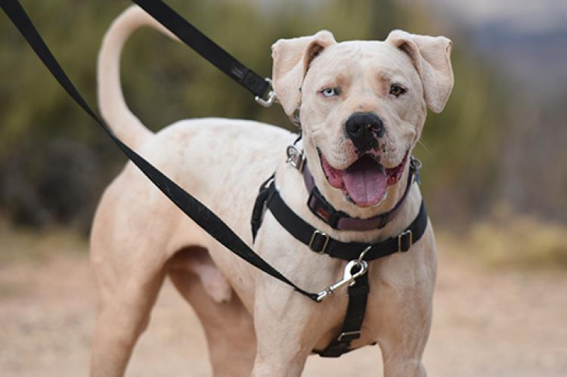
“Let’s go for a walk!” This suggestion delights dogs of all ages and sizes. While the idea of strolling along in the fresh air with your dog at your side sounds perfectly pleasant, the reality of it may not measure up if your dog pulls you down the road or trail at breakneck speed. Changing this behavior will take some training, of course, but luckily there are some products on the market that can help as your dog learns to walk more politely while leashed up.
Leash-pulling is not only annoying, it can be harmful to the dog. Many dogs have reportedly sustained injuries (e.g., to the muscles and nerves of the neck, spine and front limbs) from pulling on the leash. Wearing a harness may help prevent those problems. Not all types of harnesses are designed to help stop a dog from pulling, but some are made to do exactly that. Below are four options and some details about how they work so you can decide which one might be most useful for your dog.

Front-clip harness – Excellent for dogs who pull
With the leash connecting at the chest (rather than at the neck), front-clip harnesses work by having leash pressure direct the dog to the side instead of allowing him to lean into the harness and pull forward. Front-clip harnesses come in a variety of sizes and fit most dogs. Fit is important with this type of harness, so make sure you follow the manufacturer’s instructions when selecting and sizing. The downside to this type of harness is that it can cause chafing if fitted incorrectly. The PetSafe Easy Walk, the Halti and the Ruffwear Front Range harnesses are examples of front-clip harnesses that we recommend.

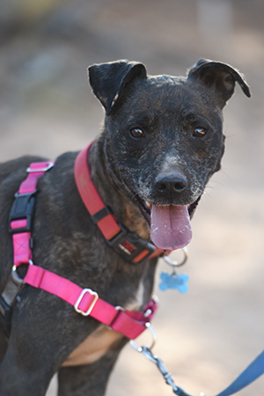

Around-the-torso harness – Excellent for smaller dogs
Harnesses that wrap around the chest or under the front legs and clip at the dog’s back can also be helpful when teaching a dog to walk on a loose leash. These harnesses give some control over the dog pulling forward and are useful for dogs with neck or back issues since they don’t apply any pressure to the neck or spine. These harnesses work well with many shapes and sizes of dogs. Also, because the leash is clipped above the dog’s body, it’s hard for him to chew on it, and it doesn’t easily tangle under his legs. The Sporn harness is an example of this type of harness.
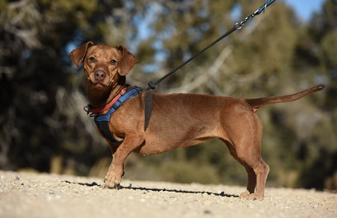

Combo harness – Excellent for walking in apartment living
If you have a dog who pulls really hard, you might want to try a combo harness, which combines a front-clip harness with one that wraps around the dog’s body. When you use it with a double-ended leash (with clips at each end) and a handle that allows the leash pressure to float between the clips, you can alternate pressure between the front clip and back clip, or put some pressure on both. This arrangement also keeps the leash short and less likely to get tangled up in a dog’s legs. This type of harness fits great on dogs with deep chests. One example is the 2 Hounds Design Freedom Harness, which is sold with or without the double-ended leash.
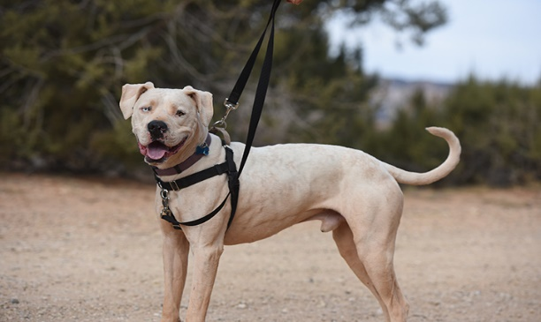

Training dogs to stop pulling on leash
While each of these types of harnesses can assist you with teaching your dog to walk on a loose leash, they won’t stop the dog from pulling without some training. For information about training dogs to walk nicely on lead, read Dog Pulling on Leash.
With a little time, patience and practice, you will find that your dog gets the picture and you can enjoy your walks together, whether it’s a leisurely stroll around the neighborhood or a brisk hike in the woods. Eventually, the words “Let’s go for a walk!” will conjure images of calm, not chaos.

